Cloud Whisper 
(Control the cloud effortlessly)

Cloud whisper is a smart-new age AI event that takes away all the burden of performing various cloud operations. It is a streamlit based webapp wherein the user can write any command for cloud operation like ‘Create a S.4 VM named test-cloud’. The agent will the process the text input given by the user using NLP and then calls Openstack API to create a VM named ‘test-cloud’ with flavor as ‘S.4’.
The architectural diagram of the webapp can be found below:
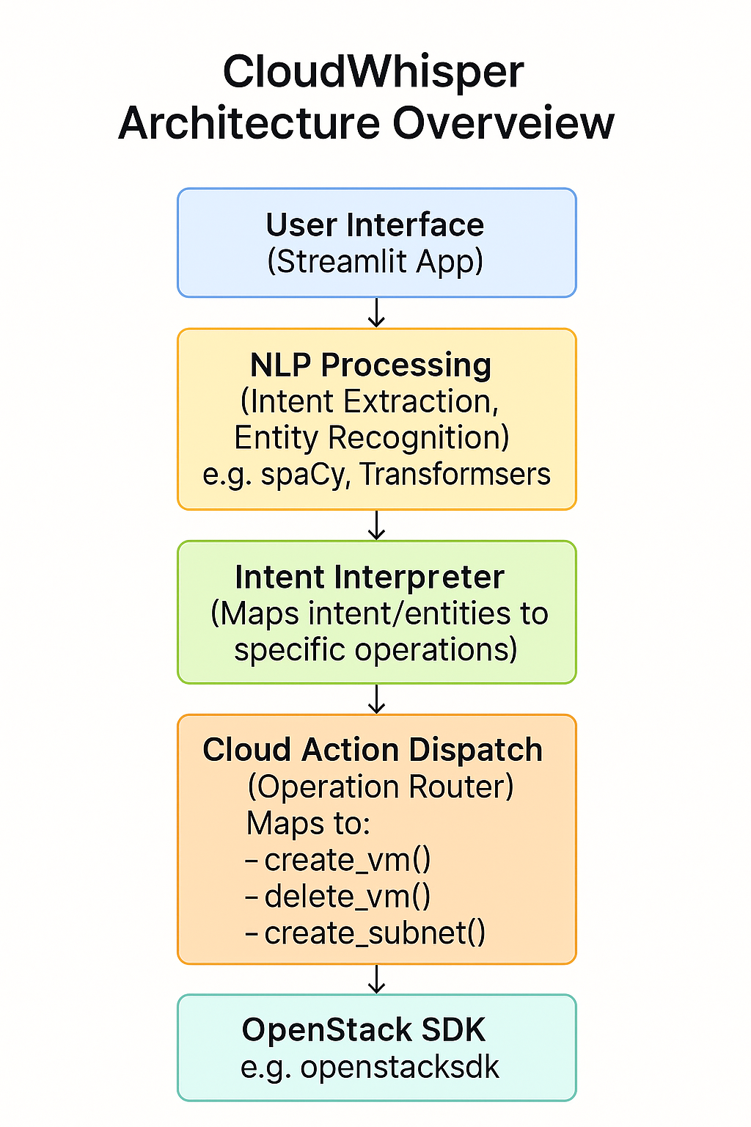
Learnings and outcomes:
- Got introduced to openstackSDK for the first time
- Got to know about NOVA, NEUTRON,CINDER etc.
- Got to know how to train LLMs for Natural Language Processing

Functionalities Provided:
- VM creation
- VM Resizing
- VM Deletion
- Network Creation
- Volume Operations (Create, Delete)
- Usage Query (vCPU used, RAM used etc)

Tech Stack Used:
- VS Code (IDE)
- Python (Programming Language)
- OLLAMA - LLama3.2-3B (LLM for training)
- Streamlit (Deployment)
- OpenStack SDK (Cloud Interaction)
- ACE Cloud (Cloud Platform for testing)

Snippet Of The Website -
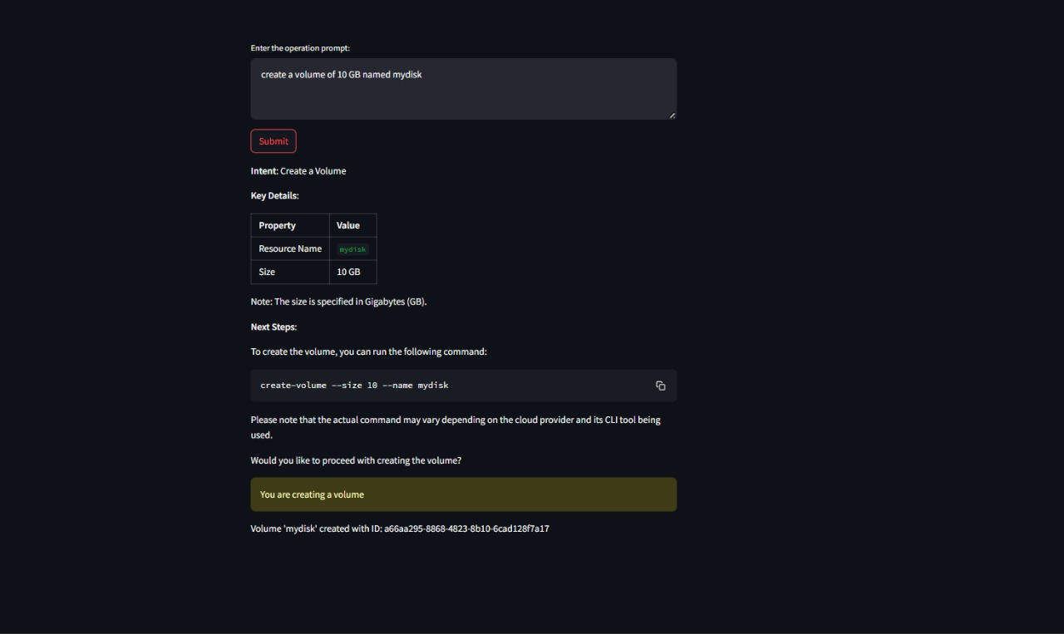


Submitted By-

Ansh Malik
College -Maharaja Agrasen Institute of Technology (MAIT)
Branch – Artificial Intelligence and Machine Learning
Batch – 2022-2026
LinkedIn – https://in.linkedin.com/in/ansh-malik-b476b0261

Arnav Bhatia
College -Maharaja Agrasen Institute of Technology (MAIT)
Branch – Artificial Intelligence and Machine Learning
Batch – 2022-2026
LinkedIn – https://in.linkedin.com/in/arnav-bhatia-77500425a

Sanket Singh Negi
College -Guru Tegh Bahadur Institute of Technology (GTBIT)
Branch – Artificial Intelligence and Machine Learning
Batch – 2022-2026
LinkedIn - https://in.linkedin.com/in/sanket-singh-negi-8a4557220

Github REPO LINK : https://github.com/Ansh-Malik1/Cloud-Whisper

DEMO VIDEO : https://www.loom.com/share/0033c0f44a1c4303ab4ce7589f735998?sid=197c3a10-be4d-4b0b-8faf-a2d8a34d7912

